Test Case: tc002_SPX_Dev5_Crear_Requisicion_Spot_Tipo_Cobro_Project
Step 1 - Enter username and password and click to button Enter: Credentials Entered
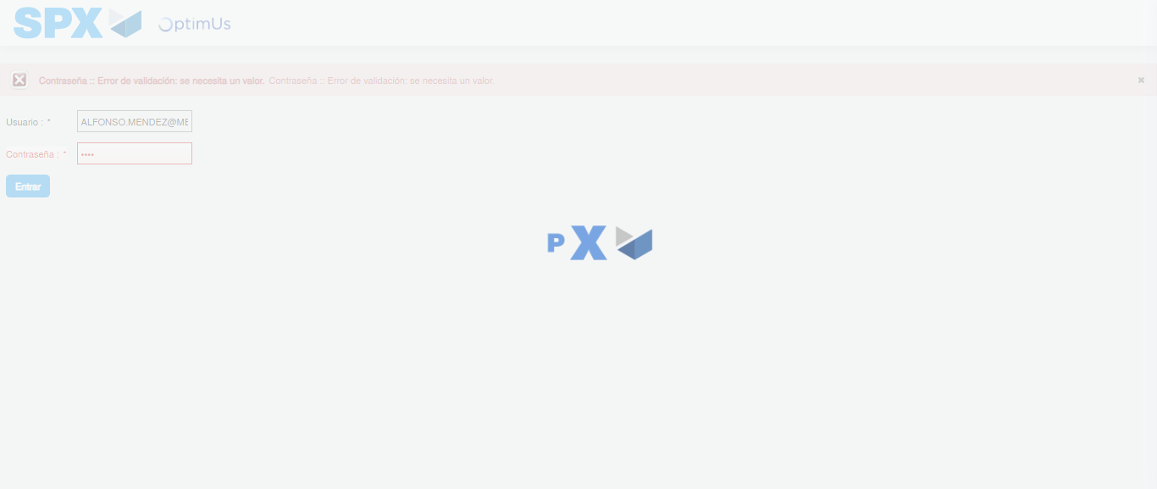Image file-name: QC_Testing-tc002_SPX_Dev5_Crear_Requisicion_Spot_Tipo_Cobro_Project-1783377839033

Step 2 - Select to UEN and Access to Spot Buy Requisitions : UEN Correctly selected and Correct access
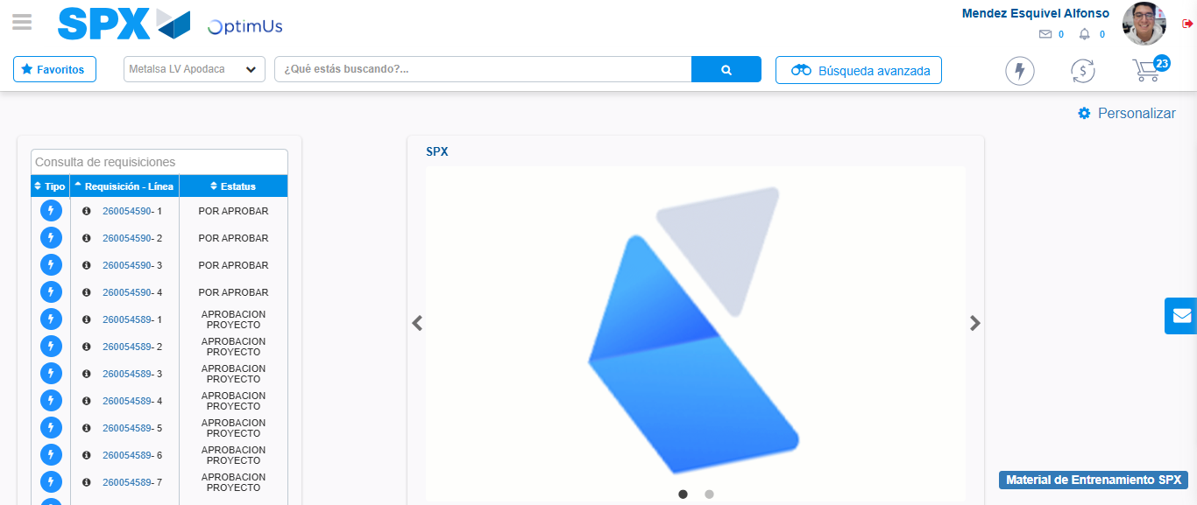Image file-name: QC_Testing-tc002_SPX_Dev5_Crear_Requisicion_Spot_Tipo_Cobro_Project-1783377863842

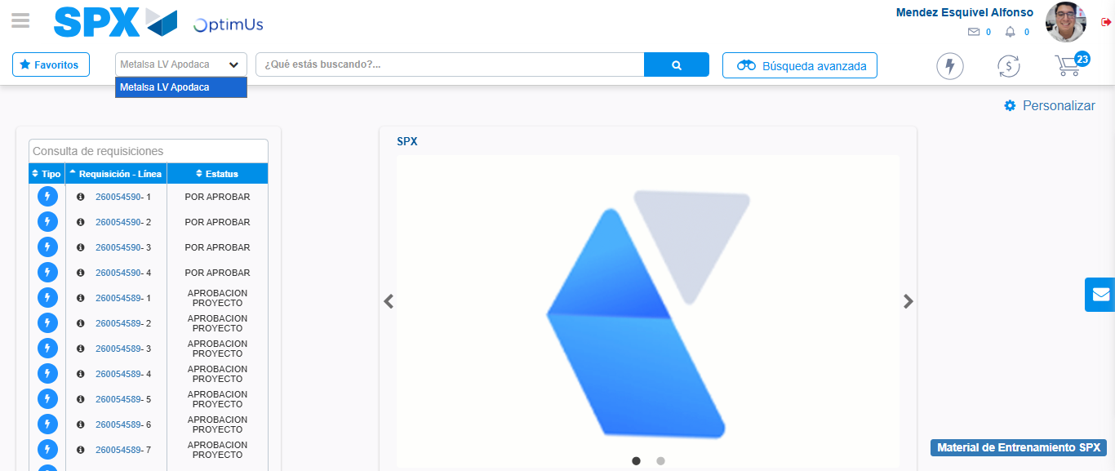Image file-name: QC_Testing-tc002_SPX_Dev5_Crear_Requisicion_Spot_Tipo_Cobro_Project-1783377866348

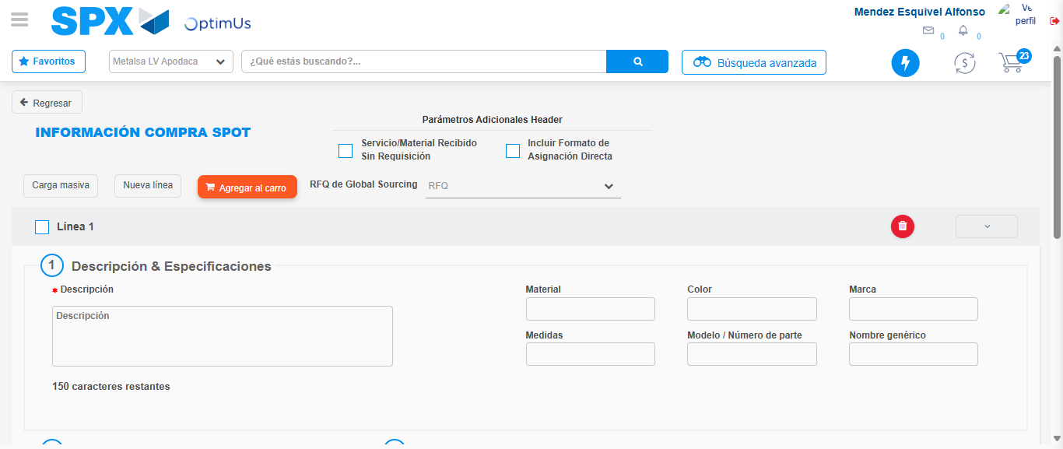Image file-name: QC_Testing-tc002_SPX_Dev5_Crear_Requisicion_Spot_Tipo_Cobro_Project-1783377886251

Step 3 - Data Capture Spot Buy Requisition: Data captured correctly
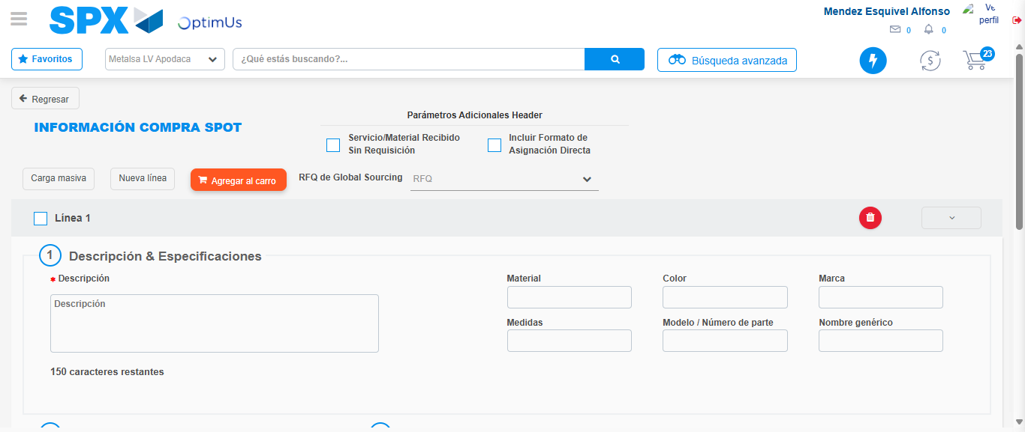Image file-name: QC_Testing-tc002_SPX_Dev5_Crear_Requisicion_Spot_Tipo_Cobro_Project-1783377886547

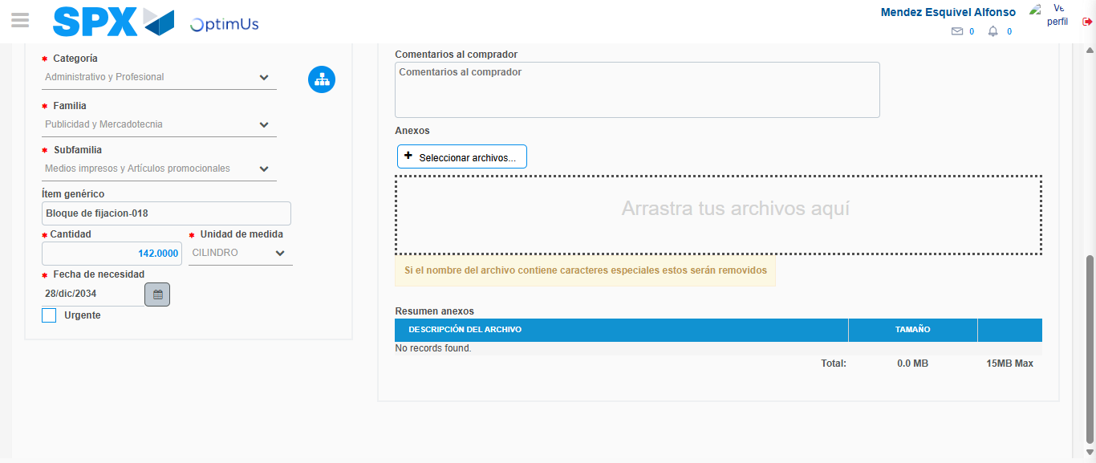Image file-name: QC_Testing-tc002_SPX_Dev5_Crear_Requisicion_Spot_Tipo_Cobro_Project-1783377896585

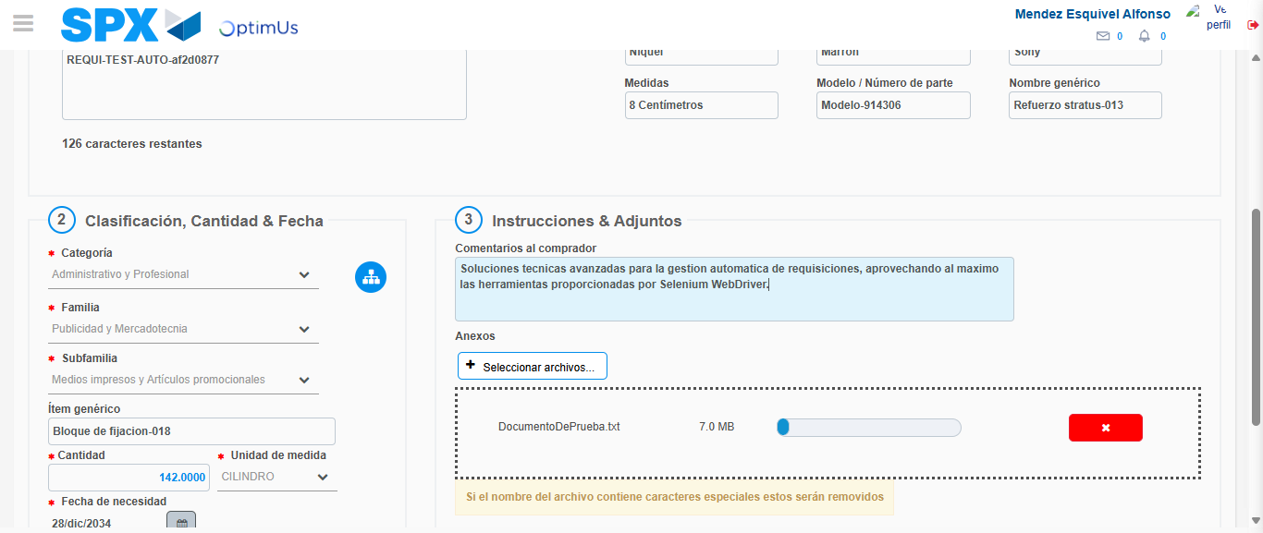Image file-name: QC_Testing-tc002_SPX_Dev5_Crear_Requisicion_Spot_Tipo_Cobro_Project-1783377897374

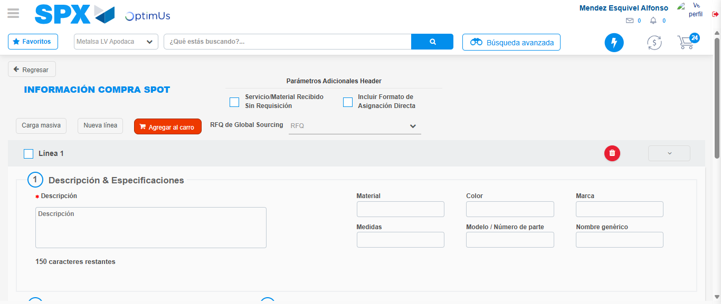Image file-name: QC_Testing-tc002_SPX_Dev5_Crear_Requisicion_Spot_Tipo_Cobro_Project-1783377904809

Step 7 - Return to Main Page SPX : Return to Main Page SPX
Image file-name: QC_Testing-tc002_SPX_Dev5_Crear_Requisicion_Spot_Tipo_Cobro_Project-1783377863842

Image file-name: QC_Testing-tc002_SPX_Dev5_Crear_Requisicion_Spot_Tipo_Cobro_Project-1783377866348

Image file-name: QC_Testing-tc002_SPX_Dev5_Crear_Requisicion_Spot_Tipo_Cobro_Project-1783377886251

Image file-name: QC_Testing-tc002_SPX_Dev5_Crear_Requisicion_Spot_Tipo_Cobro_Project-1783377907052

Image file-name: QC_Testing-tc002_SPX_Dev5_Crear_Requisicion_Spot_Tipo_Cobro_Project-1783377907231

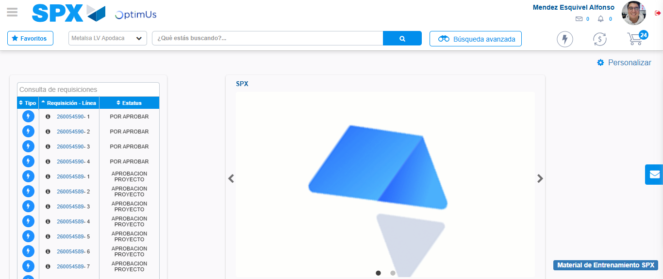Image file-name: QC_Testing-tc002_SPX_Dev5_Crear_Requisicion_Spot_Tipo_Cobro_Project-1783377928358

Step 8 - Log Out : Log Out SPX
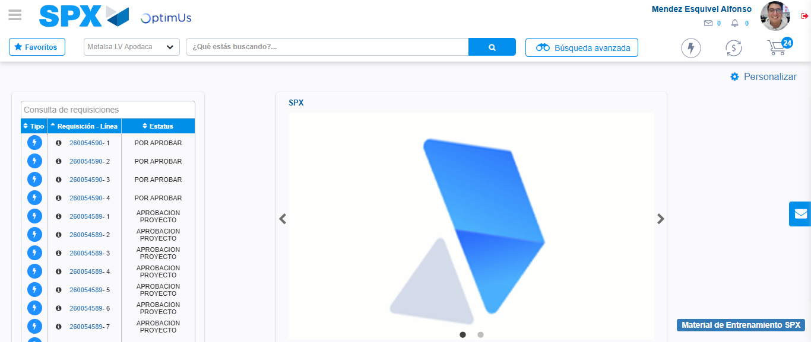Image file-name: QC_Testing-tc002_SPX_Dev5_Crear_Requisicion_Spot_Tipo_Cobro_Project-1783377928592

